**8**

**Assignment No.3**

**Basic UNIX Commands/General Purpose Utility Commands**

* **cal**

**To display a calA single parameter specifies the 4 digit year (1 - 9999) to be displayed. Two parameters denote the Month (1 - 12) and Year (1 - 9999). If arguments are not specified, the current month is displayed. A year starts on 01 Jan.**

| **Tadateg** | **Description Of Oeh** |
| --- | --- |
| -m | Display Monday as the first day of the week. |
| -j | Display julian dates (days one-based, numbered from January 1). |
| -y | Display a calendar for the current year. |

**EXAMPLES:DATE**

**To display current month's calendar**

$ cal

April 2016

Su Mo Tu We Th Fr Sa

1 2

3 4 5 6 7 8 9

10 11 12 13 14 15 16

17 18 19 20 21 22 23

24 25 26 27 28 29 30

**To display feb 2015 calendar**

$ cal 2 2015

February 2015

Su Mo Tu We Th Fr Sa

1 2 3 4 5 6 7

8 9 10 11 12 13 14

15 16 17 18 19 20 21

22 23 24 25 26 27 28

* **date**

**Use to get date**

**play system date.**

**Example:**

1. ***$date***

***Tue Jul 05 09:58:19 IST 2016***

1. ***$date +%m***

***07***

1. ***$date +%h***

***Jul***

1. ***$date +”%h %m”***

***Jul 05***

**Exercise: Explore other options available with date**

* **echo**

**Use to display a message**

**EXAMPLE:**

1. ***$echo “hello good morning”***

***hello good morning***

1. ***$echo “hello Good evening”***

***Hello Good evening***

* **bc**

**Use as a calculator**

**Example:**

1. ***bcc***

***12 + 5***

***17***

1. ***$bc***

***12 * 12***

***144***

1. ***$bc***

***9/5***

***1***

***cat***

1. ***$bc***

***scale=2***

***17/7***

***2.42***

* **script**

**Use to record the session**

**Syntax:**

**Script [filename]**

**EXAMPLE:**

1. ***$script file1***

***Script started, file is typescript***

1. ***$exitscript***

***Script is done, file is typescript***

* **passwd**

**Used to change the password**

**EXAMPLE:bcc**

**cat**

* **who**

**Give listing of users.**

**EXAMPLE:**

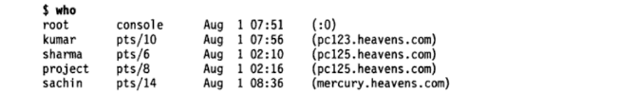

**To know the current user**



* **uname**

**Simply displays name of the operating system**

**EXAMPLE:**





* **tty**

**Give details about terminal**

**Needs no argument value**

**EXAMPLE:**



* **clear**

**to clear terminal window**

* **man command**

**Provides help on command**

**Eg. man cat**

* **whatis:**

**Displays use of command**

**Same as man –f command**

**Eg.**

1. **whatis cat**
2. **whatis cp**

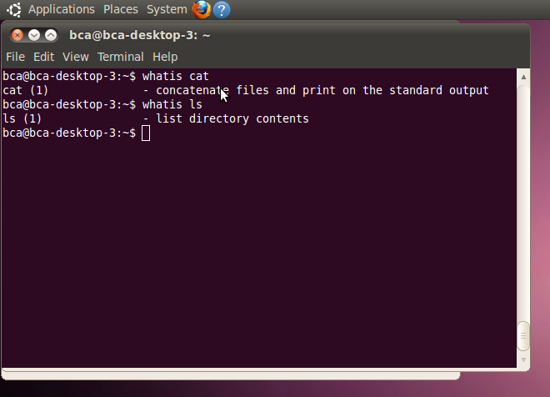

* **printf**

**Alternative of echo**

**Available only with Bash Shell**

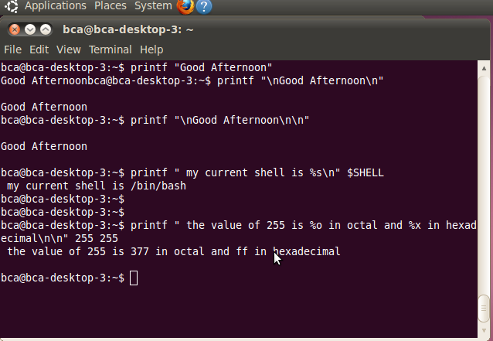

* **history**

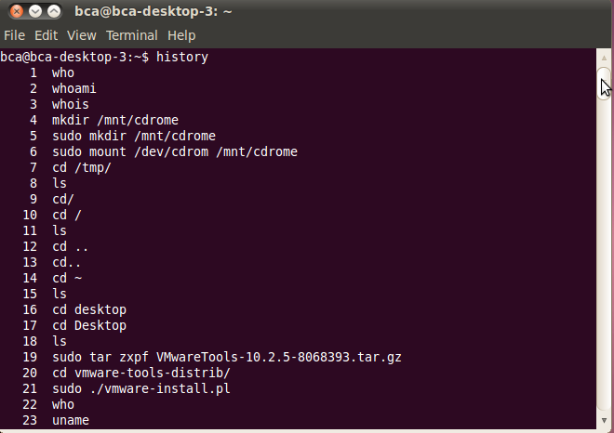

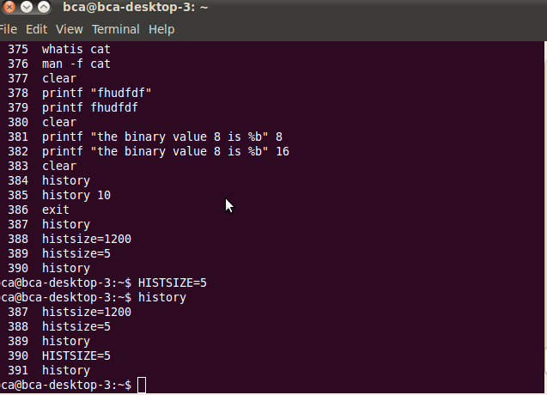

* **stty**

**displays and setting terminal characteristics**

